**Introduction to Power Line Communication**

**What is PLC?**

Power Line Communication (PLC) carries data on a conductor that is also used simultaneously for AC electric power transmission or electric power distribution to consumers. It is also known as power-line carrier, power-line digital subscriber line (PDSL), mains communication, power-line telecommunications, or power-line networking (PLN). Power lines were originally devised to transmit electric power in the frequency range of 50-60 Hz. Initially the first data transmissions over power lines were done only to protect sections of the power distribution system in case of faults. Power Line Communication was the best way for fast exchange of information between power plants, substations and distribution centers. The logic included the fact that power transmission towers are some of the most robust structures ever built. Hence protection signals could be reliably sent using this signaling network. Moreover, many remote locations were not hooked up to telephone networks. Thus it was determined that signaling and exchanging information for power system protection and telemetering purposes over existing power lines was the optimal solution.

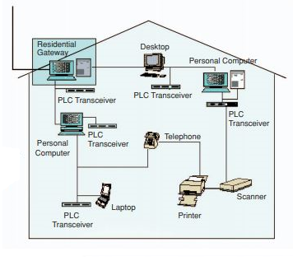

Figure 1: Home PLC System [1]

**Types of PLC**

1. Low Frequency PLC: Mainly used for telecommunication, tele-protection and tele-monitoring between electrical substations through power lines at high voltages, such as 110 kV, 220 kV, 400 kV.
2. Medium Frequency PLC (> 100 kHz): Narrowband power-line communications began soon after electrical power supply became widespread. One natural application of narrow band power-line communication is the control and telemetry of electrical equipment such as meters, switches, heaters and domestic appliances.
3. High Frequency PLC (> 1 MHz): Power line communications can also be used in a home to interconnect home computers and peripherals, and home entertainment devices that have an Ethernet port. Powerline adapter sets plug into power outlets and establish an Ethernet connection using the existing electrical wiring in the home. This allows devices to share data without the inconvenience of running dedicated network cables.
4. Ultra High Frequency PLC (> 100 MHz): These systems claim symmetric and full duplex communication in excess of 1 Gbit/s in each direction. Multiple Wi-Fi channels with simultaneous analog television in the 2.4 and 5.3 GHz unlicensed bands have been demonstrated operating over a single medium voltage line conductor.

**How PLC Works**

The power line carrier was not specifically designed for data transmission and provides a harsh environment for it. Varying impedance, considerable noise and high levels of frequency dependent attenuation are the main issues. Over such a complicated line network, the amplitude and phase response may vary very widely with frequency. Moreover, the channel transfer function itself is time varying since lugging in or switching off devices connected to the network would change the network topology. Home devices often act as noise sources, affecting the signal to noise ration of receivers.

Just like a wireless channel, signal propagation does not take place between transmitter and receiver along a line-of-sight path. As a result, additional echoes must be considered. This echoing occurs because a number of propagation paths exist between the transmitter and the receiver. Reflection of signal often occurs due to the various impedance mismatches in the electric network. Each multi-path would have a certain weight factor attributed to it to account for the reflection and transmission losses. It has been observed that at higher frequencies the channel attenuation increases. Hence the channel might be described as random and time varying with a frequency dependent signal-to-noise ratio (SNR) over the transmission bandwidth.

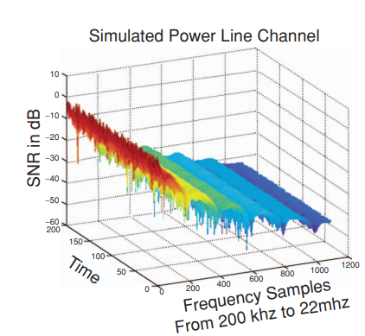

Figure 2: Power Line Channel Characteristics [1]

Noise in Power lines is a significant problem for data transmission. Typical sources of noise are brush motors, fluorescent and halogen lamps, switching power supplies and dimmer switches. The noise in power lines can be impulsive or frequency selective in nature. The noise in power lines can be classified into four categories:

1. Colored Noise: Relatively low power spectral density which decreases with frequency. It is considered to be the sum of all low power noise sources and may be time varying.
2. Narrowband Background Noise: Mainly due to amplitude modulated sinusoidal signals from broadcast stations I the medium and short wave bands.
3. Impulse Noise: Noise that is synchronous with the generator’s actual supply frequency, which usually repeats at multiples of 50/60 Hz. It is of short duration and has a power spectral density that decreases with frequency. It is caused from power supplies.
4. Asynchronous Impulse Noise: This is the most detrimental type of noise for data transmission. Its duration varies from a few micro-seconds to milliseconds. The power spectral density of such impulse noise may be as much as 50 dB above the background noise spectrum. Hence it is capable of wiping out blocks of data symbols during high data transmission at certain frequencies. It is caused from switching transients in the system network.

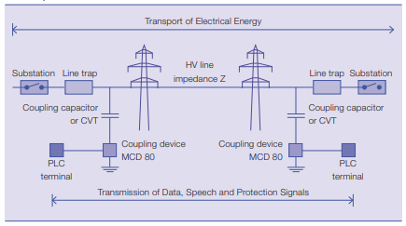

Figure : PLC System overview [2]

Modulation Techniques such as frequency shift keying (FSK), code—division multiple access (CDMA) and orthogonal frequency division multiplexing (OFDM) are appropriate modulation schemes for PLC. For low cost, low data rate applications, such as power line protection and telemetering, FS is seen as a good solution. Frequency selective fading as experienced by the power line channel severely impairs the capacity of FSK for data rates beyond a few kilobytes e second. A high degree of error control coding would be needed. Combined with the low spectral efficiency of FSK, it would limit the data rate achieved.

For data rates up to 1 Mbps, the CDMA technique may provide an effective solution. The signal of each user is spread using a spreading code at the transmitter. The receiver de-spreads the message using the same code. CDMA provides robustness against narrowband noise and other forms of interference. However, the processing gain must be high to effectively counter interference from other users. While transmitting over power lines at high data rates, the symbol duration is so small that delayed versions of one symbol gets smeared over a large number of other symbols. This makes the detection process complicated since it requires complex equalization techniques to counter the inter—symbol interference.

However, for high data applications beyond that, OFDM is the technology of choice for PLC. Serial data is passed through a serial-to-parallel converter. It splits data into a number of parallel channels with individual modulators. Each modulator has a different carrier frequency and carries a small portion of the original data rate. This increases the symbol length so that it becomes longer than the longest delay path. This solves the inter-symbol interference problem to a large extent. OFDM also avoids transmitting at frequencies in deep fade. All parallel Modulators are required to attain a minimum threshold of signal-to-noise ratio, otherwise, they are shut off. Modulators with a high signal-to-noise ratio are made to carry more bits using adaptive bit loading technique

For the Medium access control of multiple users to the network transmission capacity, a resource sharing strategy is used. Contention based protocols may cause collisions hence they are not suitable. Arbitration protocols like Polling, Aloha and Carrier Sense Multiple Access (CSMA) are used for resource sharing. CSMA/CA listens to the signal level to determine when the channel is idle, and it transmits small data packets to avoid collisions and retransmissions.

**Advantages**

1. Simplicity: Most Private homes do not have dedicated high speed network cabling installed. The labor costs required to install such wiring is often quite high. Power Line Communication uses existing electrical network for communication. So the communication service can be provided where ever the power outlets exist.
2. Flexibility: PLC is suitable for high, medium and low voltage supply. It can be used in internal electrical installation within buildings for various communication applications. If multiple power outlets are available in every room, the home power supply infrastructure presents an excellent network for sharing data among intelligent devices.

**Disadvantages**

1. Compromised Security: Power Line Communication is not necessarily secure. Many receivers can eavesdrop on the communication.
2. Data Attenuation: High Frequency signals face attenuation because power lines behave like a low pass filter.
3. High Costs of residential appliances: The cost of PLC modem is often higher than a phone line modem
4. Noise: Typical sources of noise are brush motors, fluorescent and halogen lamps, switching power supplies and dimmer switches. The noise in power lines distorts digital and analog signals.

**Applications**

The PLC Market is expanding dynamically. Advanced energy services include applications such as automatic meter reading, programmable controllers and demand supply management. There are several applications of PLC networking in homes: shared internet, printers, files, home control, games, distributed video and remote monitoring/ security.

The Homeplug Powerline Alliance was founded by Cogency, Conexant, Enikia, Panasonic, Intellion, Netgear, RadioShack Co., Sharp, Cisco Systems, Motorola, Texas Instruments and other partners. It was formed to provide a forum for creating open specifications for high speed home power line networking products and services reaching data rates of 14 Mb/s. Homeplug standard uses OFDM in a burst mode as a physical layer modulation. It uses a combination of sophisticated forward error correction, interleaving, error detection and automatic repeat request. The Medium Access Control protocol is CSMA/CA.

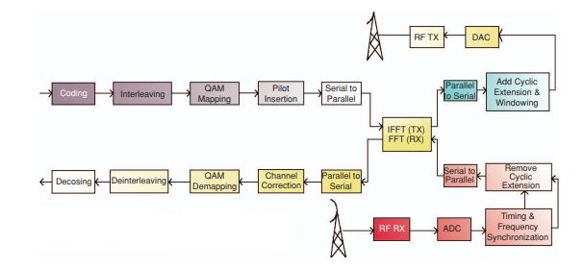

Figure 4: Homeplug PLC System Block Diagram [1]

The European Home System (EHS) consortium defines a communication protocol between appliances and central processing unit in the homes. It covers several medium types to transmit control data, power and information. All share the Logical Link Control sublayer.

Powernet aims at developing a ‘plug and play’ cognitive broadband over power lines (CBPL). Communications equipment meet the regulatory requirements concerning electromagnetic radiations and can deliver high data rates while using low transmit power spectral density.

IEEE BPL Study Group has devised standards for ‘broadband over Power line hardware’, ‘Power Line Communication Equipment Electromagnetic Compatibility Requirements - Testing and Measurement Methods’, Medium Access Control and Physical Layer Specifications.

References

[1] <https://www.researchgate.net/publication/3227750_Power_line_communication_An_overview>

[2]<https://library.e.abb.com/public/e592d40970c750a8c12571930041e152/50-53%202M633_ENG72dpi.pdf>

[3] <https://en.wikipedia.org/wiki/Power-line_communication>